
GUIDE
Word Template Explanation Guide

Table of Contents
Main Heading & Chapter Heading (Heading 1) 3
Bullets 3
Subhead 2 3
Subhead 3 3
Figures and Captions 4
Quotes or Callout 4
Cautions and Warnings 4
Tables 4
Other Elements 5
Document Colors 6
Appendix 7
Glossary 7
A 7
Index 7
A 7

Main Heading & Chapter Heading (Heading 1)
Body Copy text…. Use Normal style for all normal text. Lorem ipsum dolor sit amet, consectetur adipiscing elit, sed do eiusmod tempor incididunt ut labore et dolore magna aliqua. Ut enim ad minim veniam, quis nostrud exercitation ullamco laboris nisi ut aliquip ex ea commodo consequat. Duis aute irure dolor in reprehenderit in voluptate velit esse cillum dolore eu fugiat nulla pariatur.

Bullets
- [BT1_Bullet1] Bullet text, indented to the first indent level, bullet slightly to the left. Bullet text, indented to the first indent level, bullet slightly to the left
- [BT2_Bullet2] Bullet text, text indented to the second indent level, bullet slightly to the left. Can be used in body or procedures
- [BT3_Bullet3] Bullet text, indented to the third indent level, bullet slightly to the left. Can be used in body or procedures.
- [BT4_Bullet4] Bullet text, indented to the fourth indent level, bullet slightly to the left. Can be used in body or procedures.

Subhead 2
Use for headings below your Heading 1. Ut enim ad minim veniam, quis nostrud exercitation ullamco laboris nisi ut aliquip ex ea commodo consequat. Duis aute irure dolor in reprehenderit in voluptate velit esse cillum dolore eu fugiat nulla pariatur.

Subhead 3
Use for headings below your Heading 2. Ut enim ad minim veniam, quis nostrud exercitation ullamco laboris nisi ut aliquip ex ea commodo consequat. Duis aute irure dolor in reprehenderit in voluptate velit esse cillum dolore eu fugiat nulla pariatur.

Subhead 4
Use for headings below your Heading 3. Ut enim ad minim veniam, quis nostrud exercitation ullamco laboris nisi ut aliquip ex ea commodo consequat. Duis aute irure dolor in reprehenderit in voluptate velit esse cillum dolore eu fugiat nulla pariatur.

Introduction

This introduction heading can be used for the intro heading of your document. Use normal text for the intro text that will go below this heading.

Figures and Captions
Figure caption use 8 pt italics. Moddolar sit amet sed diam conn consequitore molentie.

Quotes or Callout
“Callout statement or quote text style”

Cautions and Warnings
WARNING: Add in description of the warning.
CAUTION: Add in description of the caution.
Note: Add in the note text.
Important: Add in the important text.

Tables
Table 1. Ruled table showing some of the available styles
Category  Name | Category  Name | Category  Name | Category  Name | Category  Name | Category  Name | Category  Name | Category  Name
Category | - bullet  - bullet | - bullet  - bullet | - bullet  - bullet | - bullet  - bullet | - bullet  - bullet | - bullet  - bullet | - bullet  - bullet  - bullet
Category | - bullet  - bullet | - bullet  - bullet  - bullet | - bullet  - bullet  - bullet | - bullet  - bullet  - bullet | - bullet  - bullet  - bullet | - bullet  - bullet  - bullet | - bullet  - bullet  - bullet
Category | - bullet  - bullet | - bullet  - bullet  - bullet | - bullet  - bullet  - bullet | - bullet  - bullet | - bullet  - bullet | - bullet  - bullet | - bullet  - bullet

Table 2. Secondary table option.
Category | Category | Category | Category | Category
Category | - bullet  - bullet | - bullet  - bullet  - bullet | - bullet  - bullet | - bullet  - bullet
Category | - bullet  - bullet | - bullet  - bullet | - bullet  - bullet | - bullet  - bullet

Other Elements

Document Colors
See screenshot below for color palette.
 | RGB | Hex
NOTE:  Hyperlink | RGB (10, 140, 191) | # 0a8cbf
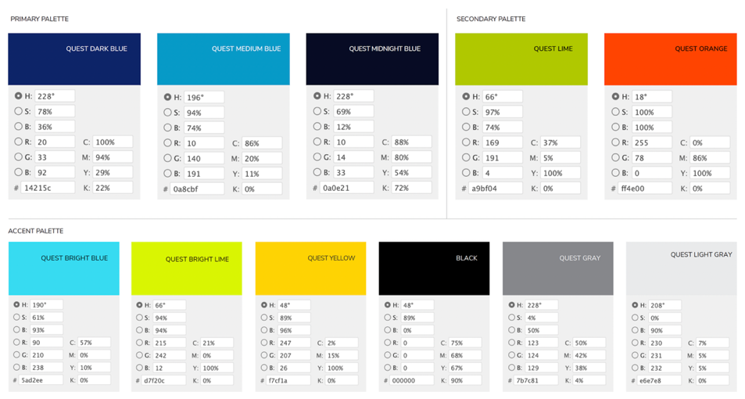

Appendix
The Appendix uses normal text style, Heading as listed above.

Glossary
The glossary letter callout uses the Heading 2 format. The term is in bold normal text. The definition is in normal text.

A
Term: Definition of the term

Index
The index letter callout uses the Heading 2 format. The index text is in normal text format

A
Index text

Please note: If this is to be used for any external distribution, you must include the legal language and update the areas that are necessary. Any external use should be limited. If there is need to distribute professionally formatted documentation, please open a request in Oasis.

About Quest Software
Quest Software creates technology and solutions that build the foundation for enterprise AI. Focused on data management and governance, cybersecurity and platform modernization, Quest helps organizations address their most pressing challenges and make the promise of AI a reality. Around the globe, more than 45,000 companies including over 90% of the Fortune 500 count on Quest Software. For more information, visit www.quest.com or follow Quest Software on X (formerly Twitter) and LinkedIn.


© 2025 Quest Software Inc.
ALL RIGHTS RESERVED.
Quest, Quest Software and the Quest logo are trademarks of Quest Software Inc. For a complete list of Quest marks, visit https://www.quest.com/legal/trademark-information.aspx. All other trademarks are properties of their respective owners.

